Holman Weather Monitoring
Garden Club
Equipment
Thermometers as available in store
Rain gauges as available in store
Weather link and Weather forecaster models
Constructed and synced Professional Weather Station
Sample Solar weather station
Water samples for rain gauge activity
Display stand
Table cloth and Banners

Pics
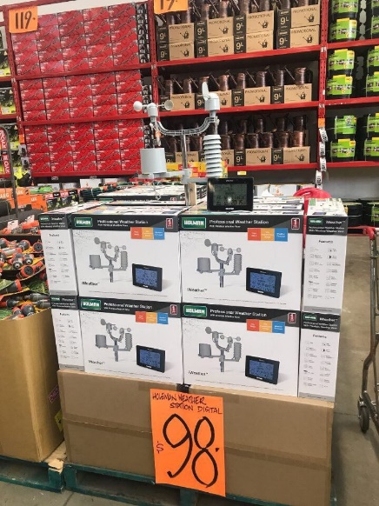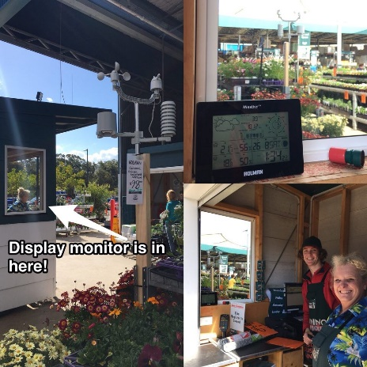

Script
Introduce the Holman company
- Australian Family owned
- 140 employees
- Irrigation, Plumbing, Lighting, Garden Décor
- Export internationally through K-Rain

People monitor the weather for all sorts of reasons
- Knowing what to wear
- Farming and gardening
- Outdoor / water sports
- Weather events – storms, floods, hail
- Bush fires
- Comfort zone…

Comfort Zone
Even though we live in all sorts of climates, from the frozen tundra to the tropics, our tolerance of temperature is actually quite narrow.
We manage this with clothing, or by heating and cooling our homes. We choose appropriate times for various activities.
We also have a narrow Humidity zone
- If the air is too dry our skin and airways start to suffer
- If the air is too humid, our sweat doesn’t evaporate to cool us
So monitoring the weather is a big deal…

Thermometers
Aluminium thermometers
- -30°C to 50°C
- Mercury free
- Strong and reliable Aluminium base
- Suitable for indoor or outdoor area (not in direct sunlight)
- Large numbers make it easy to read
- 1 year warranty.
- Two sizes – 250mm or 380mm
Brass Thermometer with Hygrometer
- -30°C to 50°C (-30°F to 120°F)
- Humidity 0% – 100%
- large display making it easy to read
- Attractive desk top unit
- Suitable for both indoor and outdoor use
- 1 year warranty

Have a volunteer read off the temperature from sample products

Rain Gauges
Wedge
- Measures rainfall in mm
- Tapered base increases accuracy
Professional
- Measures rainfall in mm
- Housing to protect inner cylinder
- Funnel to increase accuracy
Digital
- Self-emptying collector can be mounted out of reach in clear air
- Display unit sits indoors, and shows date, time, temperature and rainfall

Have a volunteer measure small amounts of water supplied, using sample rain gauges
Weather Link
- Outdoor sensor measures temperature and humidity
- Indoor unit displays Day, Date, Time, Temperature and Humidity, indoors and out.
- Easy to read backlight LCD screen
- Attractive desktop unit

Weather Forecaster
- Outdoor sensor measures Temperature, Humidity and Pressure
- Unit uses Pressure history data to forecast weather
- Indoor unit displays Day, Date, Time, Temperature, Pressure, Humidity and forecast
- Easy to read backlit LCD screen
- Attractive desktop unit

Discuss how to predict weather
Rising pressure leads to clear, sunny conditions
Falling pressure leads to cloudy, rainy, stormy conditions
Rapidly falling pressure leads to major storms
Professional Weather Station
External Sensor measures
- Wind speed and direction
- Rainfall
- Temperature
- Humidity
- Air Pressure
Interior module displays
- Wind direction and speed.
- Temperature indoors and out, with a comfort zone alarm
- Humidity indoors and out, with 12 hour history
- Rainfall
- Barometric pressure
- Forecasts based on pressure data
- Moon phases
- Day, Date and Time
- Daily alarm for reminders
Indoor and External units will automatically sync if batteries connected within 3 mins

If time allows, construct a weather station while talking. Otherwise, display a unit previously constructed
Solar Weather Station
All the functions of the Professional weather station, plus
- UV index
- Wind chill
- Dew point
- Because it is solar powered, you will never have to replace batteries in the external unit.

Conclusion / Review

