Holman Garden Club
Timers
Equipment List for display table
Tap Mount to display the ease of timer connection
Selection of timers as available in store
Grip and Lock fittings – brass and plastic, individual items plus sets, 12 mm and 18mm
Selection of Sprinklers

Pics
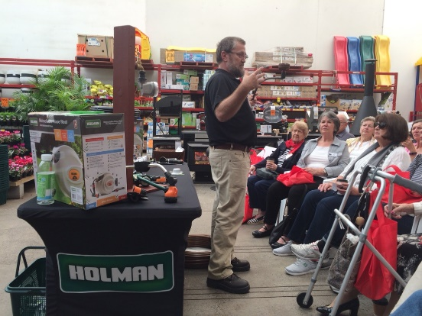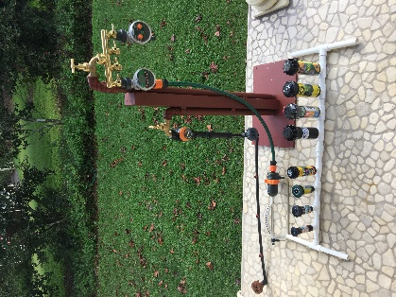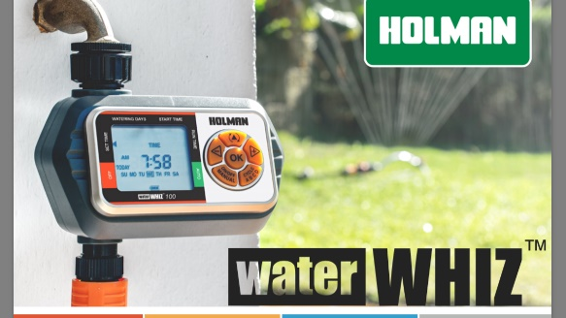
Script
Introduction to Holman
- Australian Family owned company (50 yrs)
- 140+ employees
- Irrigation, Plumbing, Lighting, Garden Décor
- Export internationally through K-Rain
Benefits of automated watering
- Getting around to it can be difficult
- Saving time for other things
- Watering while absent – holidays, work, grandkids etc
- Plants grow and thrive when watered regularly
Holman Tap timers come in Two distinct categories – mechanical and electronic
Mechanical
- Two hour mechanical tap timer
- No batteries required
- Manual operation with auto-stop
- Run times selected every watering session (no programmable options)
- Single or dual outlet
Electronic
- Automatic start and shutoff
- Two dial OR Digital models
Two Dial Electronic Tap Timers
- Auto on and off
- Pre-set frequency and run-time options
- Easy to program, easy to check
- Multiple starts per day
Essential 1601 for small lawns and garden beds
Low Pressure 1603 for tank water
Digital Tap Timers
- Automatic on and off
- LCD display
- Fully programmable
- Up to 4 starts per day
- Set run times for any given day, hour or minute
Essential 1605 for small lawns and garden beds
Professional 3005 for larger lawns and garden beds
Water Whiz Timers
- Easy to install / read / program
- Larger screen and buttons
- Multiple Zones, each with individual programs to suit a wide variety of plants
- Robust construction with 1000 kPa pressure rating
Specialised Tap Timers
Professional 3009 Misting tap timer
- Automatic on and off
- LCD display
- For frequent, short run times
- Program for on and off times, start and stop times – repeating cycle
- For pots, hanging baskets, vertical gardens, greenhouses, ferneries and misting systems.
Smart control Bluetooth tap timers
- Automatic on and off
- Control using smart phone app
- Multiple start options per day
- Control up to 8 timers from one phone
- Timers will automatically run in sequence
- BTX will run cycles like a misting timer
Companion products
- Grip and Lock Hose Connectors – essential for permanent fixtures like timers. Run through the demo comparing standard connectors to GNL
- Hose End Sprinkler range
- Oz Hose

