Holman Garden Club
Timers
Equipment List for display table
Tap Mount to display the ease of timer connection
Selection of timers as available in store
Grip and Lock fittings – brass and plastic, individual items plus sets, 12 mm and 18mm
Selection of Sprinklers

Pics
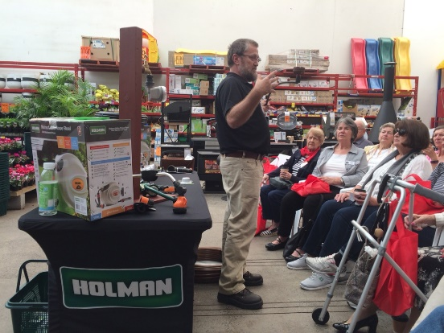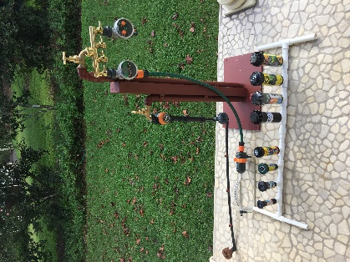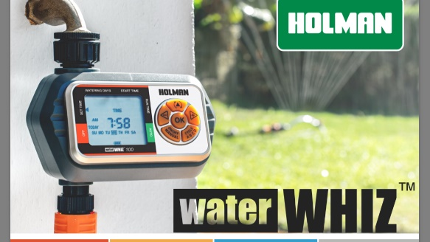
Script
Introduction to Holman
- Australian Family owned company (50 yrs)
- 140+ employees
- Irrigation, Plumbing, Lighting, Garden Décor
- Export internationally through K-Rain
Benefits of automated watering
- Getting around to it can be difficult
- Saving time for other things
- Watering while absent – holidays, work, grandkids etc
- Plants grow and thrive when watered regularly
Holman Tap timers come in Two distinct categories – mechanical and electronic
Mechanical
- Two hour mechanical tap timer
- No batteries required
- Manual operation with auto-stop
- Run times selected every watering session (no programmable options)
- Single or dual outlet
Electronic
- Automatic start and shutoff
- Two dial OR Digital models
Two Dial Electronic Tap Timers
- Auto on and off
- Pre-set frequency and run-time options
- Easy to program, easy to check
- Multiple starts per day
Essential 1601 for small lawns and garden beds
Low Pressure 1603 for tank water
Digital Tap Timers
- Automatic on and off
- LCD display
- Fully programmable
- Up to 4 starts per day
- Set run times for any given day, hour or minute
Essential 1605 for small lawns and garden beds
Professional 3005 for larger lawns and garden beds
Specialised Tap Timers
Professional 3009 Misting tap timer
- Automatic on and off
- LCD display
- For frequent, short run times
- Program for on and off times, start and stop times – repeating cycle
- For pots, hanging baskets, vertical gardens, greenhouses, ferneries and misting systems.
Smart control Bluetooth tap timers
- Automatic on and off
- Control using smart phone app
- Multiple start options per day
- Control up to 8 timers from one phone
- Timers will automatically run in sequence
Water Whiz Series
- Easy to install
- Easy to read
- Easy to program
- Multiple Zones, each with individual programs to suit a wide variety of plants
- Robust construction with 1000 kPa pressure rating

Companion products
- Grip and Lock Hose Connectors – essential for permanent fixtures like timers. Run through the demo comparing standard connectors to GNL
- Hose End Sprinkler range
- Oz Hose

